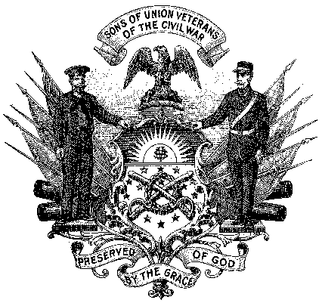
Department / Camp Name Here

Sons of Union Veterans of the Civil War

Media Advisory

TITLE OF THE EVENT TO BE HELD
AND WHERE IT WILL OCCUR

What: (In one brief paragraph describe the event. Here is an example):
Community Rededication Ceremony for the Medford, Massachusetts Soldiers and Sailors Monument. The 130 year old Civil War monument was recently restored by the town at a cost of $20,000. Mayor John Smith and Senator Robert Jones will be in attendance.

When: (Time, DAY(S) spelled out, Date(s). Here is an example):
11:00 AM, SATURDAY, JUNE 15, 2023

Location: (Location, Street address, Town, State, Zip. Here is an example):
Medford Common, 155 Main Street, Medford, MA 02155

Who: (In one brief paragraph describe who we are. Here is an example):
The Sons of Union Veterans of the Civil War is a fraternal organization dedicated to preserving the history and legacy of Union heroes who fought to preserve the country in the Civil War, 1861 - 1865. Organized in 1881 and chartered by Congress in 1954, the S.U.V.C.W. is the legal successor to the Grand Army of the Republic, the largest post-Civil War organization of Union veterans.

Media contact: Your Full Name, Position in the organization;
cell: xxx-xxx-xxxx
email: xxxx@xxx.com
website: IfYourCampHasOne.com

